**Understanding Churn Analysis: Unveiling Insights and Enhancing Customer Retention with Machine Learning**



In today's competitive business landscape, where acquiring new customers can be costly and time-consuming, retaining existing customers has become more crucial than ever. This is where churn analysis comes into play. Churn analysis is a strategic approach that enables businesses to identify and understand the factors that lead to customer attrition, or churn, and take proactive measures to mitigate it. In this article, we will delve into the significance of churn analysis, explore its importance, and discuss how machine learning can revolutionize the way we analyze and combat customer churn.

**What is Churn Analysis?**

Churn analysis, also known as customer attrition analysis, is the process of analyzing customer behavior and historical data to identify patterns, triggers, and underlying factors that contribute to customers leaving a product or service. These customers are often referred to as "churned" customers. These customers were initially using your product/service but fail to renew at the end of their agreed contractual tenure. Churn analysis involves the examination of various data points such as customer demographics, usage patterns, transaction history, customer interactions, and feedback to gain insights into why customers churn and what can be done to prevent it.

The basic equation for calculating the churn rate over a given time period is this:

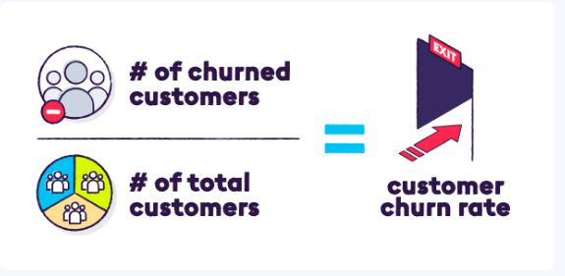

For example, if a company starts a month with 1,000 paid customers and loses 100 over the course of the month, then its churn rate for the month was 10%.

**Customer Churn can be of 2 types, i.e.**

**Voluntary**

The customer out rightly makes a decision that they want to go ahead with your product/ service or renew the contract because of many reasons like

⚡️Not getting value or great experience from the product/ service

⚡️Expectations mismatch

⚡️ Getting a better price from competitors

⚡️ CS not doing a great job

⚡️ Failure to achieve the outcome

⚡️ Missing feature functionality

This to a certain extent is avoidable if caught early.

**Involuntary**

There are some unavoidable circumstances due to which the customer is forced to discontinue the subscription. This can be:

⚡️ Company is out of budget

⚡️ Merger/acquisition of the company

⚡️ The company shuts down operations

⚡️ The SPOC driving it has left the organization

**How can we analyze customer churn?**

There are a few ways that can help collect data and analyze the churn:

🔥 **Robust Tracking System**: You need to ensure all the customer-specific data, i.e. Usage, plan value, geography, MRR, ARR, account health, feedback, and open issue tickets/feature requests are in place. This ensures an understanding of how the account was progressing and whether were there any warning signs/ red flags that were ignored. This should be automated to such an extent that you look at it and are able to derive an actionable business insight.

🔥 **Customer Cohorts**: We need to build customer cohorts wherein we segment/ bucket the customer by Geography, Industry, MRR, ARR, Tenure with the organization, and so on. This definitely helps identify trends that point towards a particular cohort of customers struggling and we can accordingly shift our focus towards fixing it. For example, Customers who fall in Mid-market category and are on monthly subscription plans are churning at a high rate as compared to the ones on an annual subscription plan

🔥**Exit Interviews**: Do capture feedback from the customers who have churned. Understand what really pushed them to take this decision. We should try to if it is a Product that is not matching the expectations or if is it a service that is creating an issue for the customer as both aspects create a really bad experience.

**The Importance of Churn Analysis**

Churn analysis holds paramount importance for businesses across industries. Here's why:

1. Cost Savings: Acquiring new customers is considerably more expensive than retaining existing ones. Churn analysis helps businesses focus on retaining valuable customers, thereby reducing the costs associated with customer acquisition campaigns.
2. Revenue Preservation: Retaining customers translates to consistent revenue streams. By understanding churn patterns, businesses can implement strategies to keep customers engaged, increasing customer lifetime value and overall revenue.
3. Enhanced Customer Experience: Churn analysis provides insights into customer pain points and preferences. Addressing these issues can improve the overall customer experience and loyalty.
4. Competitive Advantage: Businesses that can predict and prevent churn are better positioned to outperform competitors. Proactively addressing customer concerns can lead to a distinct competitive advantage.
5. Data-Driven Decision Making: Churn analysis relies on data-driven insights rather than assumptions. This enables businesses to make informed decisions based on empirical evidence.

**Machine Learning's Role in Churn Analysis**

Traditional methods of churn analysis involved manually segmenting customer data and performing basic statistical analysis. However, with the advent of machine learning, businesses can harness the power of algorithms to extract deeper insights from large and complex datasets. Here's how machine learning can enhance churn analysis:

1. Predictive Modeling: Machine learning algorithms can predict the likelihood of a customer churning based on historical data. These models take into account various factors such as customer behavior, usage patterns, and interactions to forecast churn probabilities.
2. Feature Importance: Machine learning algorithms can identify the key drivers of churn by ranking the importance of various features. This helps businesses understand which factors have the most significant impact on customer attrition.
3. Segmentation and Personalization: Machine learning can segment customers based on similar characteristics and behaviors. This enables businesses to tailor retention strategies to specific customer segments, making them more effective.
4. Real-time Monitoring: Machine learning models can continuously monitor customer behavior and trigger alerts when specific patterns associated with churn emerge. This allows businesses to intervene in real-time and prevent churn.
5. Experimentation and Optimization: Machine learning facilitates A/B testing and experimentation with different retention strategies. Businesses can quickly identify which approaches are most effective in reducing churn.

**Ways to reduce Customer Churning**

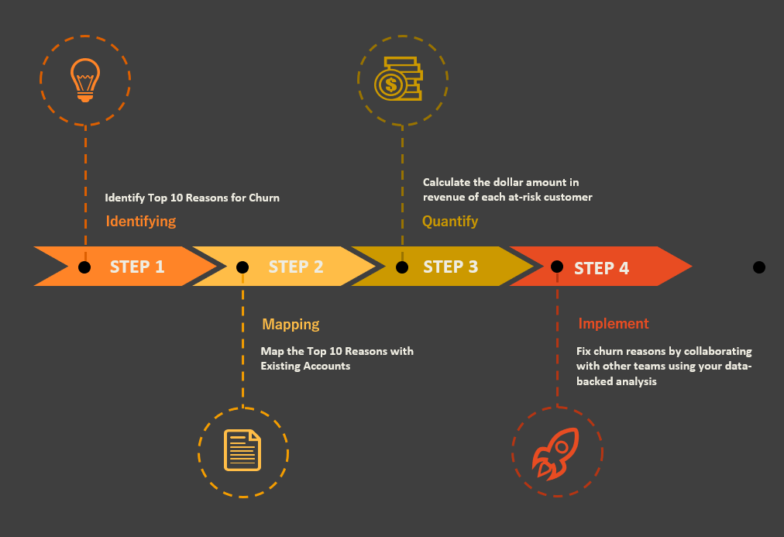

**Conclusion**

Churn analysis is an indispensable tool for businesses seeking to enhance customer retention and revenue sustainability. By leveraging machine learning techniques, companies can transform churn analysis from a reactive process into a proactive strategy that anticipates customer behavior and implements personalized interventions.

As technology continues to advance, the synergy between data science and business strategy will enable organizations to not only retain customers but also foster long-lasting relationships and foster business growth.

At the end of the day, we all would want to avert churn and work with Happy Customers.